TODO for Apr 15, 2025:
- Problem Statement (Case Study) Slide (10K transactions/sec and how we approach…) - DONE by M.P. see below in this document

- Components Diagram – break down system into major components/modules, show relationships. High-level view of boundaries and communication. Choose Architecture style (Microservices arch) – Todo by S.B.
- Data Flow Diagram – how data flows through a system. Shows integration points, data processing paths and key operations. – DONE by A.H.
- Deployment (Infra Scaling) Diagram – elastic horizontal auto-scaling. What components do we scale? What critical resources do we optimize for/increase? We follow EKS deployment (Tomcat, Kubernetes instances scale). CloudWatch for monitoring. – Todo by V.A.
- Security Diagram – shows how security is enforced: firewalls, encryption (SSL), auth flows (token based). Critical for system operating with credit-card and PII customer data, which our system is. – Todo by R.H.

Case Study: The E-Commerce Black Friday

Table of Contents

Requirements 1
Expected Volumes 1
Functional Requirements 1
High-level Architecture Considerations 2
1. Systems and Subsystems Required 2
2. Types of Information Exchanged 4
3. Potential Failure Points 5
Mitigation Actions 6
4. Difference Between Average Load and Peak Load 6
5. Cost-Effective Architecture Decisions 7
6. Security Considerations 7

Requirements
An e-commerce company is launching a new platform to support high-traffic events like Black Friday.
The new system must be resilient scalable and provide seamless transactions.

Expected Volumes
- Expected Daily Active Users: 1 million
- Peak Concurrent users: 250,000
- Transactions per second (TPS): 10,000
- Supported platforms: web, mobile (IOS & Android)

Functional Requirements
- Secure user authentication (SSO, MFA)
- Product catalogue, shopping cart and checkout
- Multiple payment gateway integrations with failover.
- Order tracking, notifications and user reviews.
- Admin dashboard with analytics and role-based access.

High-level Architecture Considerations
- What are the various systems and subsystems required to deliver this functionality?
- What kind of information is exchanged (frequency, speed, volume etc.)?
- What are potential failure points?
- What kind of mitigation actions are necessary to ensure failure preventions? (Highlight is as reactive, proactive or preventive)
- Do you see a difference in the way the system needs to behave during average load and peak load?
- What would you architect for knowing that there can be cost implications?

1. Systems and Subsystems Required
To support a scalable, resilient e-commerce system for Black Friday-level traffic, as an architecture we should include the following modular systems and subsystems:
Core Systems:
- Frontend Platforms
  - Web (React, Angular, or Next.js)
  - Mobile Apps (iOS, Android - built with React Native/Flutter or native)
- Authentication System
  - SSO (OAuth 2.0, OpenID Connect)
  - MFA (TOTP, SMS, Email OTP)
- Product Management
  - Product Catalog Service (with search and filtering)
  - Inventory Management System
- Shopping Cart Service
  - Session-based or user-profile-based carts
  - Cart persistence and sync
- Checkout System
  - Pricing engine, discounts, shipping calculations
- Payment Gateway Integrations
  - Multiple providers (Stripe, PayPal, Razorpay, etc.)
  - Payment Orchestrator with automatic failover
- Order Management System
  - Order lifecycle tracking
  - Fulfillment coordination
- Notification System
  - Email, SMS, Push (via services like Twilio, Firebase)
- User Feedback System
  - Review, rating, and moderation module
- Admin Dashboard
  - Analytics, order stats, user engagement
  - Role-based access control (RBAC)
- Logging & Monitoring
  - Centralized logging (ELK, Datadog)
  - Distributed tracing (OpenTelemetry, Jaeger)
  - Alerts & anomaly detection
- Database Systems
  - Relational DBs for transactions (PostgreSQL, MySQL)
  - NoSQL for product catalog (MongoDB, DynamoDB)
  - Caching layer (Redis, Memcached)
- Infrastructure & DevOps
  - Containerization (Docker, Kubernetes)
  - Auto-scaling (AWS/GCP/Azure)
  - CI/CD pipeline
  - API Gateway, CDN (Cloudflare, Akamai)

2. Types of Information Exchanged
Data Types and Patterns:
Data Type | Frequency | Speed (Latency) | Volume
User logins & auth tokens | High (peak times) | Low latency | Medium
Product catalog fetches | Very High | Low latency | Very high (esp. search)
Cart updates | Frequent per user | Medium | Moderate
Transactions (checkout) | Bursty | Low latency | High during peak
Payment info | High security | Ultra-low latency | High importance
Order tracking updates | Event-driven | Medium latency | Medium
Notifications (email, push) | High volume | Async acceptable | High
Admin queries & dashboards | Regular polling | Medium | Low/Medium
Data Flow Diagram
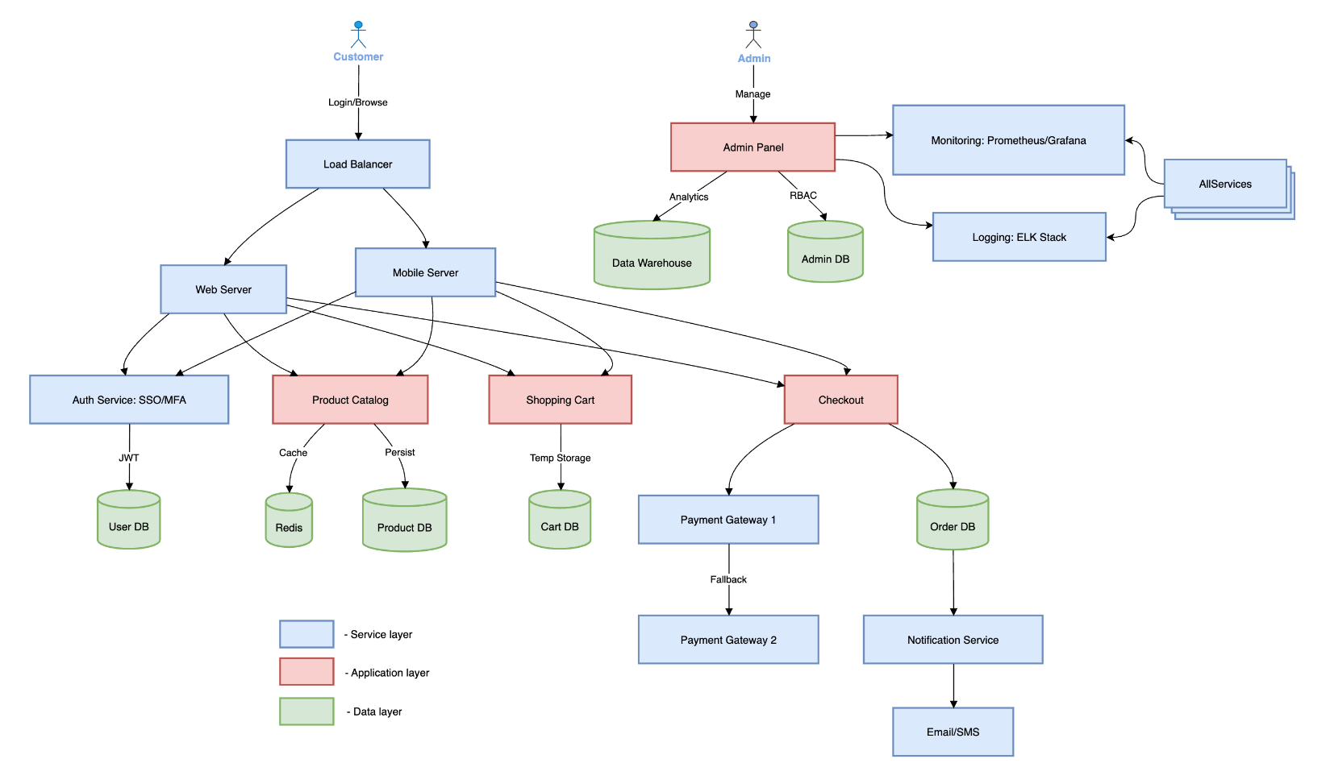
Key Components Explained:
- User Flow:
- Customers interact via Web/Mobile → Load Balancer distributes traffic.
- Auth Service handles SSO/MFA securely.
- Core Features:
- Product Catalog: Cached (Redis) + DB-persisted.
- Shopping Cart: Session storage with auto-expiry.
- Checkout: Connects to Payment Processor with failover.
- Resilience:
- Database Cluster: Master-slave replication.
- Payment Gateways: Fallback mechanism.
- Microservices: Decoupled for scalability.
- Admin & Monitoring:
- Dashboard: Role-based access to analytics.
- Monitoring: Prometheus + ELK for real-time logs.
- Redundancy: All critical components (DB, Payment) have backups.
- Scalability:
- Horizontal Scaling: Stateless services auto-scale.
- Peak Handling: 10K TPS via distributed systems.
- Traffic Spikes: Load balancer + caching handle 250K concurrent users.
- Low Traffic Mode: System scales down 100x via cloud auto-scaling.

3. Potential Failure Points
Component | Failure Scenarios
Authentication | Latency or downtime in SSO or MFA provider
Cart Service | State loss or inconsistency between sessions
Payment Gateway | Gateway downtime or transaction failure
Product Catalog | High latency on DB queries or search index corruption
Order Service | Deadlocks, duplicate orders, stuck order states
Notification Service | Failed delivery, spam filters
Infrastructure/Scaling | Insufficient autoscaling or hitting rate limits
CDN or Cache | Cache miss, stale data, propagation delays
Database | Connection saturation, slow queries
Admin Dashboard | Incorrect role access or slow analytics queries

Mitigation Actions
Component | Action Type | Mitigation
Auth & MFA | Proactive | Use redundant auth providers, fallback MFA methods
Payment Gateway | Reactive | Retry logic, auto-failover between gateways
Caching Layer | Preventive | Warm up cache, lazy loading strategies
Database | Preventive | Query optimization, read replicas, sharding
Cart & Checkout | Proactive | Session stickiness, service retries
Infrastructure | Preventive | Auto-scaling, chaos testing
Notification | Reactive | Retry queues, dead-letter handling
Monitoring | Proactive | Real-time alerts, dashboards for ops team
System Updates | Preventive | Canary deployments, blue-green deployments

4. Difference Between Average Load and Peak Load
Yes, the system must handle drastic behavioral shifts during peak load:
Aspect | Average Load | Peak Load (Black Friday)
Traffic volume | Moderate & predictable | Sudden spikes, high concurrency
Resource allocation | Minimum instances auto-scaled | Pre-warmed resources, over-provisioned buffers
Caching | Normal cache usage | Cache hit ratio must be near 100%
Queues & Async ops | Lower throughput | High throughput, resilient queuing
Monitoring | Lower priority alerts | Aggressive real-time monitoring
Rate-limiting | Basic controls | Strict rate limits to prevent overload
Feature toggles | Full features | Might disable less-critical features (e.g., reviews)

5. Cost-Effective Architecture Decisions
Given cost constraints, focus on balancing performance and cost:
Smart Choices:
- Use serverless components (e.g., AWS Lambda, Firebase Functions) for bursty workloads (e.g., notifications).
- Cache everything: Use CDN + Redis for product listings, static assets, and cart items.
- Use message queues (Kafka, SQS) for async and retryable tasks like notifications and order processing.
- Employ multi-tier storage: Premium SSD for transactional DBs, cheaper blob storage for logs/media.
- Auto-scaling Kubernetes or ECS clusters—scale-to-zero where possible.
- Leverage spot instances or reserved instances for predictable workloads.
- Integrate feature flags to gracefully degrade non-essential services during high load.

6. Security Considerations
Here are the critical security considerations for your high-traffic e-commerce system, designed to handle Black Friday-scale loads while protecting data and ensuring compliance:
1. Infrastructure Security
DDoS Protection:
- Use AWS Shield/Cloudflare to mitigate volumetric attacks during peak traffic.
- Deploy rate limiting (e.g., 10,000 TPS per IP).
Network Segmentation:
- Isolate public-facing servers (web/mobile) from internal services (DBs, payment) using VPCs/NACLs.
WAF (Web Application Firewall):
- Block SQLi, XSS, and bot traffic (e.g., AWS WAF with OWASP rules).

2. Data Security
Encryption:
- In Transit: TLS 1.3 for all communications (HTTPS, API calls).
- At Rest: AES-256 for databases (e.g., PostgreSQL, Cassandra).
PCI DSS Compliance:
- Tokenize credit card data; never store raw PANs. Use PCI-compliant gateways (Stripe, PayPal).
Data Masking:
- Anonymize PII in logs/analytics (e.g., replace emails with hashes).

3. Authentication & Access Control
Multi-Factor Authentication (MFA):
- Enforce MFA for admin dashboards and sensitive operations (e.g., refunds).
- Role-Based Access Control (RBAC):
- Limit admin access (e.g., "read-only" for support staff).
Session Management:
- Short-lived JWT tokens (15–30 mins) with Redis-backed revocation.

4. Payment Security
Payment Gateway Failover:
- Use certified providers (Stripe + Braintree) with automatic fallback.
Fraud Detection:
- Integrate tools like Signifyd or Kount for real-time fraud scoring.
Idempotency Keys:
- Prevent duplicate charges during retries (critical for 10K TPS).

5. API Security
OAuth 2.0/OpenID Connect:
- Secure mobile/third-party API access with scoped permissions.
API Rate Limiting:
- Throttle non-critical endpoints (e.g., product reviews) during peaks.

6. Monitoring & Incident Response
Real-Time Alerts:
- Monitor for anomalies (e.g., 500% spike in failed logins).
Audit Logs:
- Track all admin actions (who deleted a product?).
- Automated Responses:
- Auto-block IPs after 10 failed auth attempts.

7. Compliance & Legal
GDPR/CCPA:
- User data deletion workflows. Cookie consent banners.
SOC 2 Type II:
- Required if handling enterprise customers.

8. Scalability-Specific Risks
Cache Poisoning:

- Sanitize keys in Redis (e.g., user input as cache keys).
Database NoSQL Injection:
Validate inputs for MongoDB/Cassandra queries.

Auto-Scaling Misconfigs:

Ensure new instances boot with hardened AMIs/containers.

Implementation Checklist:
Enable DDoS protection (AWS Shield/Cloudflare).

Encrypt all databases (AWS KMS/HashiCorp Vault).

Tokenize payments via Stripe/Braintree.

Deploy WAF with OWASP Core Rule Set.

Test failover for payment gateways.

Schedule quarterly penetration tests.

Example Attack Mitigations:
Threat Solution
Card skimming PCI DSS + iframe embeds (Stripe.js)
Credential stuffing MFA + CAPTCHA for >5 failed logins
Inventory hoarding bots Rate limit "Add to Cart" API calls

